Product Inventory Management System
Ideation Phase
Empathize & Discover
Date: 08/03/2026
Team ID: SWTID-2026-1942
Project Name: Product Inventory Management System
Maximum Marks: 4 Marks
mm
Empathy Map Canvas:
An empathy map is a simple, easy-to-digest visual that captures knowledge about a user’s behaviors and attitudes.
It is a useful tool that helps teams better understand their users. Creating an effective solution requires understanding the true problem and the person experiencing it. The exercise of building the map encourages participants to view challenges from the user’s perspective, including their goals and difficulties.

Example:
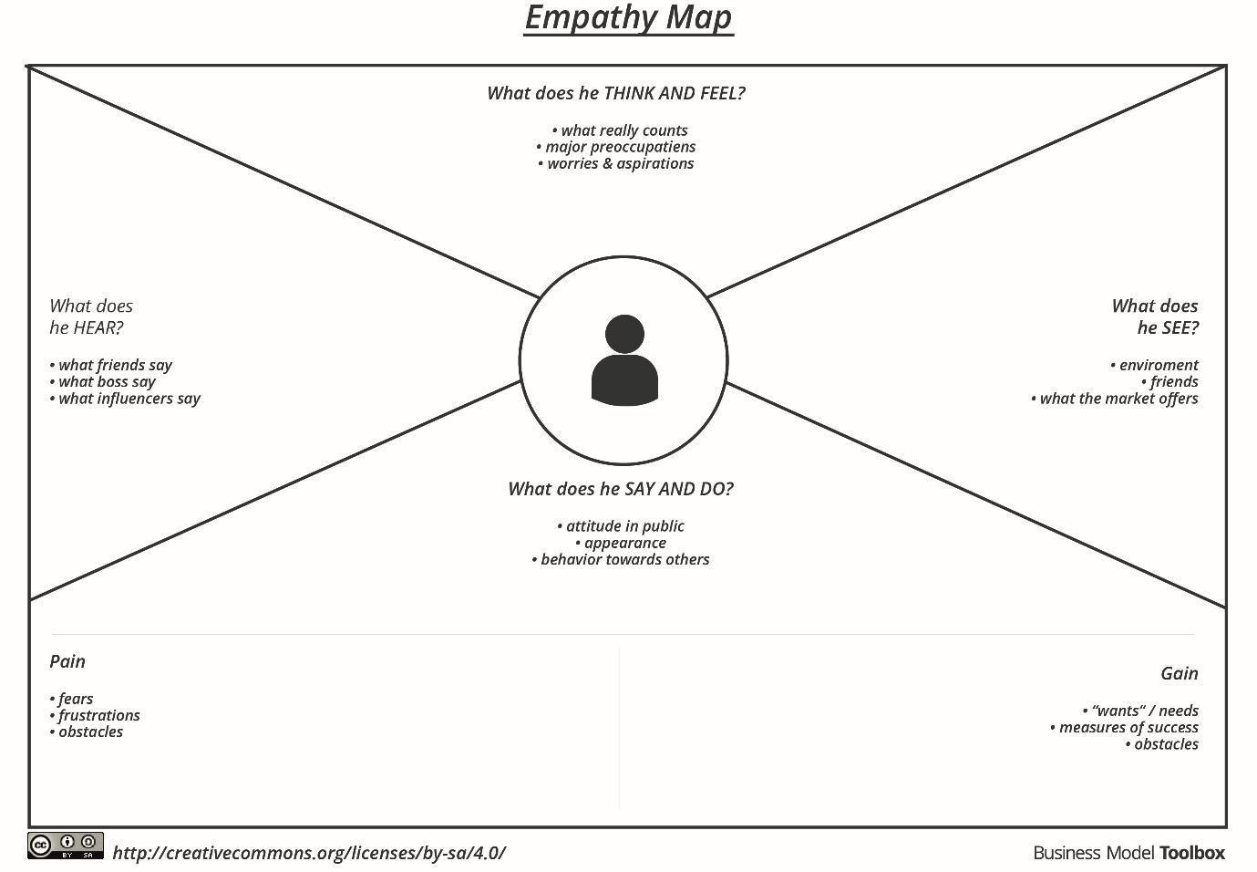

Reference: https://www.mural.co/templates/empathy-map-canvas
